MARYWOOD FRANCISCAN
SPIRITUALITY CENTER
Roots and Ripples
Volume 15, Issue 1
January-March 2022
Roots and

Dear Friends of Marywood,
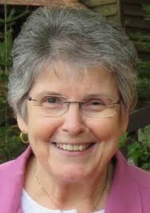
You are holding/reading a new format for our newsletter. Our intention is to offer it four times a year, including donors each time. Its size offers many options for where to keep it handy: pocket, visor, purse, glovebox, refrigerator… This time of year ignites the desire for us to remember and sift through the happenings of our year and set goals in welcoming the new. May this activity be renewing and uplifting for you. As we enter the Christmas Season, along with the Scriptural account of Jesus’ birth, I invite you to search out and absorb the wisdom of a poem by Henry Van Dyke, Keeping Christmas. On behalf of all of us at Marywood I thank you for your many ways of showing and sharing your support with us. Thank you for joining with us in person or via Zoom for programs, spiritual direction or friendly visits. We are gift and blessing for each other.
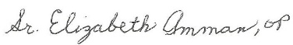
Sr. Elizabeth Amman OP
Director

“Prayer Stones”
WOMEN’S CHRISTMAS
JANUARY 6, 2022
(one date only)
Holy Family church hall, woodruff
5:00 p.m. $45.00
To register call
715-385-3750

Jan. 10, 2022 10:00-12:00 p.m. (in person)
Facilitator: Rev. Tammy Barthels
And he answered and said, “I tell you that, if these shall hold their peace, the stones will cry out.” (Luke 19:40) Bring your favorite stones
and a heart full of hope. Learn to make your own prayer stones. Materials will be provided. Register by January 7. Fee: $25
*******
“It’s About Time”
January 18, 2022
9:30-11:00 a.m. (ZOOM)
1:30-3:00 (in person) Facilitator: Pat Pintens Often we hear “It’s about time!” We live
in/with three concepts of time: chronos or measured time, cosmic or earth time, and Kairos or God’s time. Let’s explore the interrelationship of these three concepts and our experience of God in each.
Fee: $20. Register by January 13.
“Encountering God, the Holy One “Thursday, January 20
9:30 – 11:30 a.m. (ZOOM)
1:00 – 3:00 p.m. (in person)
Facilitator: Sr. Marla Lang
We long to be touched by God’s
goodness. Yet, God touches us daily!
Come, explore God with us! Fee: $20
Register by noon the day before.
*******
Thomas Merton: East Meets West”
January 31, 2022
1:30-3:00p.m. (ZOOM)
Facilitator: Grant Van Lishout
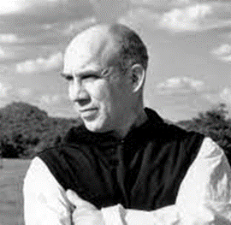
"If I can unite in myself, in my own spiritual life, the thought of the East of the Greek and Latin Fathers, I will create in myself a reunion of the divided Church."
- A Year with Thomas Merton
Fee $20 Register by January 18
*******
“Seeing Our Soul’s Shadow”
Wednesday, February 2, 2022
9:30-11:30 a.m. (in person)
1:00-3:00 p.m. (ZOOM) Facilitator: Pat Pintens In the light we clearly see our ‘outside’
shadows. We have ‘inside’ shadows as well, parts of ourselves we find frightening, that we try to keep hidden. There are graces and gifts within our ‘inside’ shadows. Let’s bring those graces and gifts to light. Fee: $20.00. Register by Jan. 27.
TO REGISTER…
715-385-3750 X1
marywood.center@gmail.com
credit cards accepted
(2.75% processing fee)

“Meet Dietrich Bonhoeffer”
Friday, February 4, 2022
9:30 – 11:00 a.m. (ZOOM)
Facilitator: Grant Van Lishout
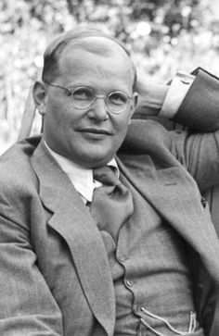
A German Lutheran Pastor who actively participated in the German resistance movement and was arrested and later hung after being implicated in a 1944 assassination attempt on Adolf Hitler. Bonhoeffer urges us to bring God into all parts of our lives. “Jesus does not call men to religion, but to life.” Fee: $20
Register by Friday, Jan. 21.
*******
“Full Moon Snow Shoe Walk” Wednesday, February 16 8-10:00 p.m. Facilitator: Pat Pintens Enjoy the quiet of a winter evening reflecting
on the divine presence in the vastness of the winter woods. Bring snow shoes, clothing to keep you comfortable, and a snack to share.
We will gather at Marywood. Fee: $15.
Register by Thursday, February 10.

“Praying Through Depression”
Tuesday, February 17
9:30-11:30 a.m. ( ZOOM)
1:00-3:00 p.m. (in person) Facilitator: Pat Pintens Depression is a difficult emotion to
experience, understand, or find grace in.
When feeling depressed it may seem impossible to experience God’s presence
and graces. How we pray can help us do so. Fee: $20. Register by Feb. 10.
*******
“Engaging in God’s Hopefulness”
Monday, February 21
9:30 – 11:00 a.m. (ZOOM)
1:00 – 2:30 p.m. (in person)
Facilitator: Sr. Marla Lang
Brides and grooms spin hopes. Dreams
come in multitudes. Leaders question.
Hope engages. Explore hope with us!
Fee: $20 Register by noon the day before.

Marywood Franciscan Spirituality Center
engages persons seeking greater meaning in life and a deeper relationship with God, others, self, and all creation by providing space for inspiration, reflection, and solitude.
It is owned and operated by Franciscan Sisters of Perpetual Adoration of La Crosse, WI, a 501 (C) 3 not-for-profit charitable organization. All contributions are tax-deductible as the law allows.

“Exploring Dreams:
The Unconscious at Work”
Monday, March 7, 2022
2:00-3:30 p.m. (ZOOM)
Facilitator: Grant Van Lishout
We all dream. Sometimes we can remember them; other times we do not. Do you ever wonder what is going on? Do they have a message for us? How do we best use our dreams and the messages they share with us? Fee: $20 Register by Friday, February 18.

*******
“Bedazzled - Mixed Media of Paper,
Fiber and Beads”
March 7, 8 and 9
9 a.m.-3:00 p.m.
Facilitator: Sr. Karen Kappell
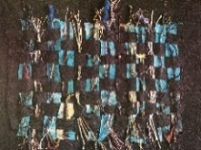
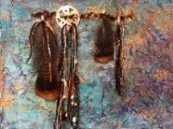
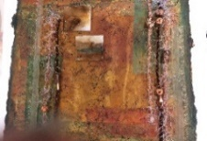
This series of art programs will use beads, paper, and fibers to create wall hangings, paintings incorporating small beads and fibers, yarns, and other small items. Many of the techniques can be transferred into card making and journaling. Each day is independent of the next. Most materials will be provided but if you have fancy string, scraps of fibers, small beads, yarns, etc. bring them along. Bring Elmer's glue and scissors. Get ready to experiment and play with multi-media. Bring lunch. Limit of nine. Fee: $40/day Register by March 1.
“Lenten Lectio”
Thursdays March 10, 17, 24, 31 and Apr 7
6:30-7:30 p.m. (ZOOM)
Facilitator: Pat Pintens Lectio divina is an ancient way of reading,
pondering and praying the scriptures or other spiritual writings. Let’s read, ponder and pray together the Lenten Sunday scripture passages
and discover new insights for our daily living. Register by March 3 (free will offering)
*******
“Marching through Darkness”
Tuesday, March 15
9:30 – 11:30 a.m. (ZOOM)
1:00 – 3:00 p.m.(in person)
Facilitator: Sr. Marla Lang
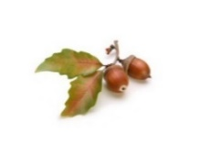
Seeds and acorns sprout in darkness. They seek their life form. Growth goes beyond imagining. Life is evolving and awakens us!
Register by noon the day before. Fee $20

For information on Marywood’s retreat accommodations
and opportunities
for spiritual direction, please visit
www.marywoodsc.org

“Celtic Crosses and Saints”
Thursday, March 17, 2022
9:30-11:30 a.m. (in person)
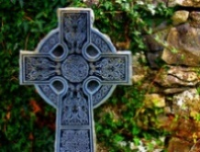
1:00-3:00 (ZOOM)
Facilitator: Pat Pintens The Celtic or ‘wheel’ cross is one of the most widely recognized of Christian symbols. The threads and knots used in the cross tell stories - both Christian and pre-Christian. Come, discover the stories of the Celtic cross. Fee: $20. Register by Friday, Mar. 11.
“A Day of Winter Warmth and Solitude”
9:00 a.m. – 3:00 p.m.
You choose the date. A quiet day. A warm cabin. Time alone to pause, rest, listen, reflect, catch up with
one’s spirit and God. You will have a private room in a cabin. Spiritual direction is available (separate fee).
Bring your lunch. Fee: $35.00. Call to schedule.
“CELEBRATE WHAT’S RIGHT WITH THE WORLD”
Sunday, March 20, 2022 1 - 3:00 p.m. Facilitator: Pat Pintens Dewitt Jones, a former photographer for National Geographic, invites us to “Celebrate What’s Right with the World.” “God gave me photography so that I could pray with my eyes,” he says. Let’s listen to his words, look through his camera lens and renew our sense of celebration. Suggested offering $20. Register by Tuesday, March 15.
Donors July, August and September 2021
Marcelline Ahmann
JoAnne and Robert Ash
Salvatore & Patricia Balistreri
Merci

Tak skal du have

Muchas Gracias

Danke schön

Grazie
Diane Beda
Joseph Benbenek
Chuck & Carol Berigan
Mary Jo Berner
Peter and Peggy Billing
Cynthia & Bill Bomber
Arlene Bonacci
Richard & Mary Kay Bowman
Susan Brant
Ronald & Susanna Brudos
Madalene & Kevin Buelow
Mary Egges Carian
Jon & Judy Cassady
Lisa and Steve Coon
Coon's Franklin Lodge, Inc.
Jim and Diane Coursolle

Fr. Aaron Devett
John Donovan
Bonnie & Richard Edwardsen
Meg and Larry George
Helen Gurtner
Joanne Guzik
Joan Hannasch
Harrold, Scrobell & Danner
Joyce Heil
Mary Ann Henrichs
William and Carol Hiller
Matthew & Allison Johnson
Barbara Kane
Dr. Jean Keuer
Knights of Columbus # 2032
Knights of Columbus #7827
Catherine Koerpel
Christine Krause & Mary Waters
James and Christine Martin
John & Ruth McEnroe
Franciscan Sisters of Perpetual
Adoration
Lakeland Fitness and Golf
Tim McMahon Appraisals
Jim and Anne Jackson Miller
Charlene & Frank Moravec
Yvonne Morman
James Murphy
Nimsgern Funeral and Cremation Services
Nimsgern Steel
Arline O'Connell
Lanny and Margaret Peterson
Peterson/Kraemer Funeral Homes
and Crematory, Inc.
Beth Piasecki
Mark Piper
Mary Ellen Poggemann
Anthony and Frances Pogodzinski

Bonnie and Donald Pollard
Ocean (Linda) Prihoda
LaVon & Dennis Rader
Bill & Maureen Radtke
Red Crown Lodge
Gayle & Robert Ritter
David Ross
Curtis Schrage
Henry and Eleanor Schroedel
Robert and Mary Scrivner
Mrs. Mary Gayle Selfridge
Mike & Kathy Skelton
Judy and Mike Smolarek
Cindy Spliedt
Koszonom

Ačiu

Go raibh maith agat

Takk skal du ha

Tack

Bedankt
Rosemary St John
Strunz Family
Diane Taggart
Shirley Thoen
Mary Ticknor
Tomahawk Appliances
Wendy Ulfig
Greg & Mary Van Grinsven
Patricia Voermans
Fr. Geoff & Valerie Ward
Russell & Eileen Weber
Thomas Weikert
Mike & Sally Winger
Kathy Woller
Joan Wolter
Woodruff Appliance
Joseph Zurfluh

If the only prayer you say in your life is "thank you," that would suffice.
--Meister Eckhart

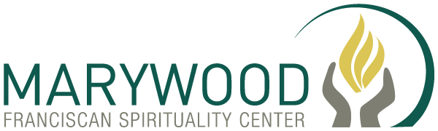
11195 Marywood Cove
Arbor Vitae, WI 54568

